SAFETY INTERVENTIONS
Reducing Noise Levels & Preventing Hearing Loss

Situation

- Construction sites are noisy, with sound levels loud enough to put workers at risk for noise-induced hearing loss. According to the National Institute for Occupational Safety and Health (NIOSH), nearly half of all construction workers suffer hearing loss. Noise induced hearing loss cannot be reversed, but it can be prevented.

- Noise is measured in decibels (dBA). A whisper is typically about 30 dBA, a normal conversation is about 60 and a chainsaw is 110. OSHA says workers should not be exposed to more than 90 dBA on average over an 8-hour work shift (OSHA PEL) and NIOSH recommends 85 dBA (NIOSH REL).

- Ignoring high noise levels can be costly due to:
- Lost productivity caused by work delays to comply with noise ordinances
- Workers’ compensation claims related to long-term hearing loss
- Accidents caused by workers’ inability to hear.

- The work performed by masonry contractors and their employees frequently generates noise above the OSHA PEL, however, a study of exposures by the University of Washington found low use of hearing protection when it was needed:
% of time hearing
Average protection was worn
Examples of dBA when needed
Tasks:
Manual Material 89.4 0%
Handling
Brick/Block/ 91.6 35%
Tile laying
PCC 95.3 82%
Tools:
Hammer/Mallet/ 90.4 23%
Sledge
Drill Motor 91.7 29%
Hand Power Saw 97.2 11%
Stationary Power
Tool 101.8 100%
Interventions

- Noise levels can be brought down below the PEL through a combination of engineering controls, hearing protective devices with a hearing conservation program, and administrative controls.

- Low noise equipment

- NIOSH’s on-line resources – Buy Quiet (http://www.cdc.gov/niosh/topics/buyquiet/) and Noise and Hearing Loss Prevention http://www.cdc.gov/niosh/topics/noise/ – can help contractors and workers find information on how to control noise and prevent hearing loss.

- The Buy Quiet web resource explains how to establish a buy quiet program in your workplace, offers a video and posters to reinforce the message, and a power tools database. The online Power Tools Database contains examples of commercially available low noise hand-held power tools commonly used in construction. It was created to provide contractors with easy access to noise control technologies when making purchasing decisions. A contractor can search by type of equipment, the manufacturer, or technical specifications.
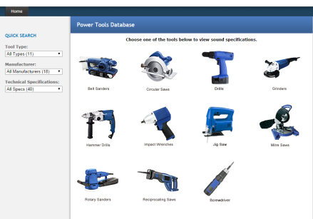
http://wwwn.cdc.gov/niosh-sound-vibration/

The difference in noise levels between two pieces of equipment may not seem like much, until you consider that a 3 dBA increase “doubles the amount of the noise and halves the recommended amount of exposure time,” according to NIOSH. In other words, a tool with a noise level of 100 dBA is almost 10 times as loud as one with a noise level of 90 dBA.
- Hearing Protection

- Hearing protection should be provided when noise levels cannot be brought down below OSHA’s PEL through the use of low noise equipment, isolating the work, or other means.

- Selecting the appropriate hearing protection is critical. One way to do this is by checking the Noise Reduction Rating (NRR) on the product or packaging label. The University of Washington School of Public Health suggests the following for most activities:

Bricklayer 22 decibel NRR
Masonry Restoration 26 decibel NRR
Cement Mason 14 decibel NRR
Tilesetters 12 decibel NRR
Portable music player headphones and hearing aids are not a substitute for hearing protection

- In addition, NIOSH has developed an on-line Hearing Protector Device compendium to help contractors with the selection process.
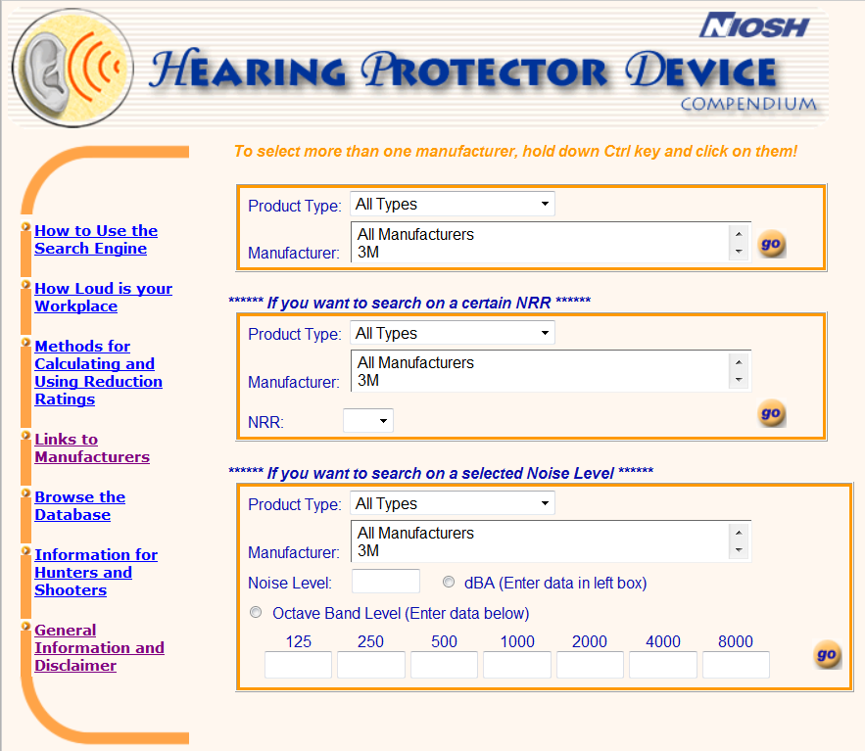http://www2a.cdc.gov/hp-devices/hp_srchpg01.asp

- This site allows the user to select hearing protection by product type, manufacturer, NRR, and noise level. It contains information to help evaluate a workplace’s noise level, methods for calculating and using reduction ratings, and links to manufacturers.

- There are also several free ‘apps’ for smart phones that allow the user to quickly and easily gauge the noise level of their work place. Simply search on “noise meter apps” --https://play.google.com/store/apps/details?id=com.pjw.noisemeter). Research conducted on the accuracy of several different low-cost apps was favorable for the SPLnFFT, the SPL, and the SoundMeter.

- To educate workers on the importance of using hearing protection, IMI’s Safety Tool Kit includes an industry-specific “Hearing Protection” toolbox talk at www.imiweb.org.

Learn More

To learn more about how to deal with noise hazards and the Partnership’s work visit:

- OSHA: Occupational Noise Exposure at http://www.osha.gov/SLTC/noisehearingconservation/index.html

- NIOSH: Preventing Occupational Hearing Loss - A Practical Guide at http://www.cdc.gov/niosh/docs/96-110/default.html

- Masonry Research to Practice Partnership at www.masonryr2ppartnership.com

- CPWR Construction Solutions at http://www.cpwrconstructionsolutions.org/hazard/Noise/

- eLCOSH (Electronic Library of Construction Occupational Safety & Health) at www.elcosh.org

Share Your Solution

There are many options available to reduce hearing loss. To share your thoughts on the options mentioned with the Masonry r2 Partnership or provide one of your own email: IMI’s National Training Director Robert Arnold at BArnold@imiweb.org; or Dave Wysocki at dwysocki@imiweb.org.

